Proxmox setup:

1. Hardware Requirements and Compatibility

Minimum Requirements:
- 64-bit CPU with Intel VT-x or AMD-V (Quad-core or better recommended)
- 8 GB RAM (16–64 GB recommended for virtualization workloads)
Disk:
- Minimum: 32 GB SSD/HDD
- Recommended: 100+ GB SSD or NVMe
Compatible Hardware:
- Dell PowerEdge and HP ProLiant servers (commonly used and supported)
- 10+ GbE NICs

2. Virtual Network Interfaces
- Each VM can have up to 32 virtual NICs
- Supports Linux bridging, VLAN tagging (802.1q), bonding (LACP).

3. SAN Storage Configuration

Fibre Channel (FC) SAN Setup:
Identify Host HBA WWPNs: (on proxmox node)
systool -c fc_host -v | grep port_name
Create Zoning Configuration (on san switch): For two hosts:
zonecreate "zone_cluster_test01", "WWPN_host1;WWPN_storage1;WWPN_storage2" zonecreate "zone_cluster_test02", "WWPN_host2;WWPN_storage1;WWPN_storage2"
cfgcreate "cfg_xiuscluster" "zone_cluster_test01;zone_cluster_test02"
cfgenable "cfg_xiuscluster"
For single host:
zonecreate "zone_proxmox01" "WWPN"
cfgcreate "cfg_single_node" "zone_proxmox01"
cfgsave
cfgenable "cfg_single_node"
Rescan LUNs on Hosts:
for host in /sys/class/scsi_host/host*; do echo "- - -" > $host/scan; done
multipath -ll

iSCSI SAN Setup:
iscsiadm -m discovery -t sendtargets -p <SAN-IP>
iscsiadm -m node --login
multipath –ll

4. Raw Disk Attachment (CLI)
Attach raw SAN disk to VM:
qm set 105 -scsi1 /dev/mapper/mpatha,cache=none,discard=on,ssd=1
Options Explained:
- cache=none: Safe for SAN-backed disks
- discard=on: Enables TRIM support
- ssd=1: Helps guest OS detect SSD behavior

5. Hotplug Configuration
Memory Hotplug:
- Works dynamically with guest OS support
CPU Hotplug:
- Set maximum vCPUs using sockets × cores in VM config
- VM must be shut down to increase max vCPU beyond current setting
Example:
- If 4 sockets × 2 cores = 8 vCPUs total
- Start VM with 4 vCPUs, hotplug up to 8 while running
- After this 8vCPU we can’t hotplug more vCPU’s
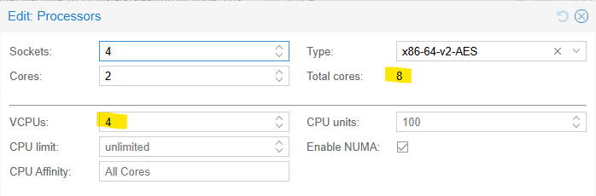

6. Snapshots and LVM-Thin
Limitations:
- Snapshots are not supported with standard LVM
- Snapshots work with LVM-Thin storage
Steps to Enable Snapshot Support:
pvcreate /dev/mapper/mpathb
vgcreate vg_iscsi_mpath /dev/mapper/mpathb
lvcreate -L 100G -T vg_iscsi_mpath/thin_iscsi_pool this is for snapshot lvm-thin storage

lvcreate -L 500G -n pbs-backup vg-proxmox-lvmthin - this is for backup normal lvm
mkfs.xfs /dev/vg-proxmox-lvmthin/pbs-backup
mkdir Backup-server
mount /dev/vg-proxmox-lvmthin/pbs-backup Backup-server (on backupserver vm host cli)

6. Add in PBS UI
- Open Proxmox Backup Server web UI
- Go to Datastore → Add → Directory
- Path: /Backup-server
- Give a Datastore name like Backup-storage
Add in GUI:
- Datacenter → Storage → Add → LVM-Thin → Select VG and pool

7. VM Migration and Cluster Creation
- Cluster must be created for migration
- Use GUI (Datacenter → Cluster) or CLI:
pvecm create <cluster-name>
- Join other nodes via GUI or CLI:
pvecm add <IP-of-master-node>
Live Migration:
- Works with shared storage
- Right-click VM → Migrate

8. Backup Solutions
Options:
- Built-in vzdump utility for scheduled or manual VM backups
- Supports backup to local storage or NFS
Recommended:
- Use Proxmox Backup Server (PBS) for deduplicated, incremental backups
- Supports file-level restore and efficient VM backup integration
Integration Steps:
- Deploy PBS
- Add PBS storage in Datacenter → Storage → Add → Proxmox Backup Server
- Schedule backups from GUI
To add Backup server in proxmox:
On proxmox backup server gui: Datastore Backup storage Summary Show connection information
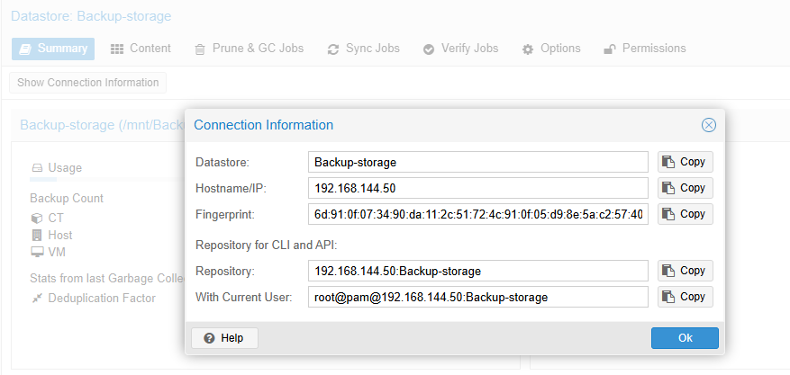
To add Proxmox backup storage server in Proxmox:
Proxmox GUI Datacenter Storage Add PBS server fill above info in like below mentioned
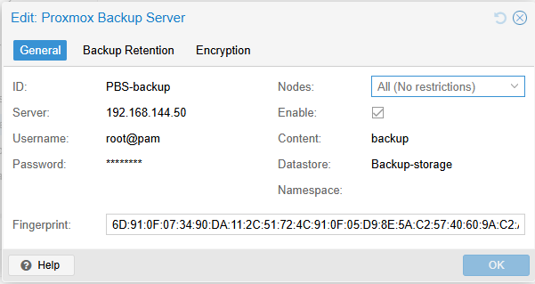

13. Backup & Restore in Proxmox
Backup Procedure
To take a backup of a VM using the Proxmox GUI:
- Navigate to: Datacenter → Node → VM → Backup
- Select the desired Backup Storage.
- Click Backup to initiate the process.
Backup Limitations
- During the backup process, Proxmox places a temporary lock (type: backup) on the VM’s configuration to prevent concurrent conflicting operations.
- If the backup fails or is aborted, the lock may not be removed automatically, resulting in the VM being stuck in a "locked" state, even though it continues to run normally.
- While in this locked state, new backups cannot be initiated for the VM until the lock is cleared.
- Manual intervention is required via CLI to remove this lock.
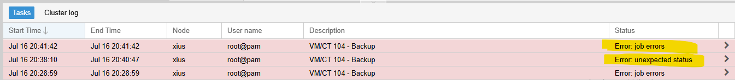
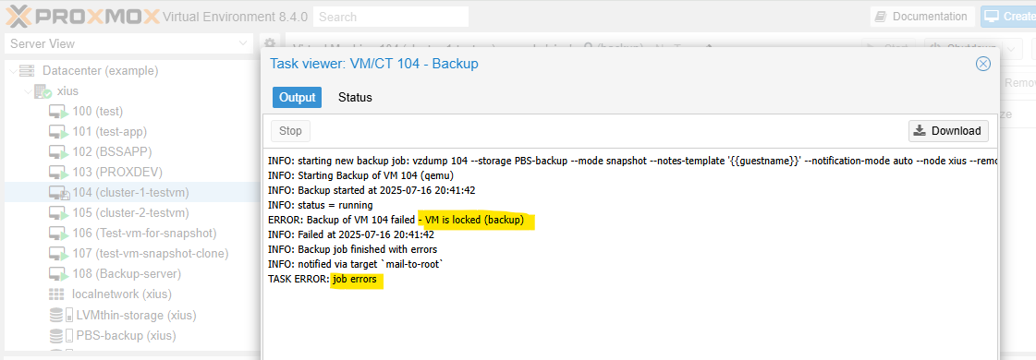

To unlock the VM: Open Proxmox server cli qm list (note vm id that need to unlock)
qm unlock <vm-id>
Restore Procedure
To restore a VM from a backup using Proxmox Backup Server (PBS):
- Go to the PBS backup datastore in the Proxmox GUI.
- Navigate to: Datastore → Backups
- Select the desired backup version.
- Click Restore.
The restore process will create a new VM from the selected backup image.
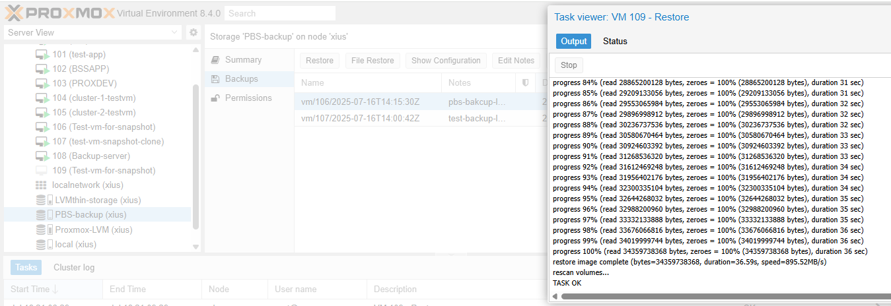

Under VM Backup option click Restore it’ll erase current vm and restore the backup vm

